Coach Freed’s Guide to Running Shoes
The running shoe question is complex and the market is difficult to navigate. I’m going to try to simply things and give the best advice that I can for how to end up in the shoes that are correct for you.

What kind of foot do you have?
The most common question I get is, “What are the best running shoes?” The answer is, “It depends.” Shoes are incredibly personal and there are now “best” shoes. There are many shoes that are good, but finding the “right” shoe for you is tricky. Let’s start with foot types and then move on to shoes. The type of foot you have is determined by the height of your arch and the width of your foot. Width is easy to figure out: narrow, standard, or wide. The arch height levels go from flat to neutral, to high. The height of your arch will determine the amount that your foot pronates. When our feet hit the ground they natural roll from the outside edge, across the middle, to the inside. This rolling action is called pronation. If our foot doesn’t roll in much at all, that is called “Under Pronation”. If it rolls so much that your whole arch flattens on the ground that is called “Over Pronation”. The easiest way to know what you do is to walk a few steps on smooth concrete in wet feet and look at the foot print that you leave. You can also have someone watch you walk from behind in bare feet and see how much you roll in.

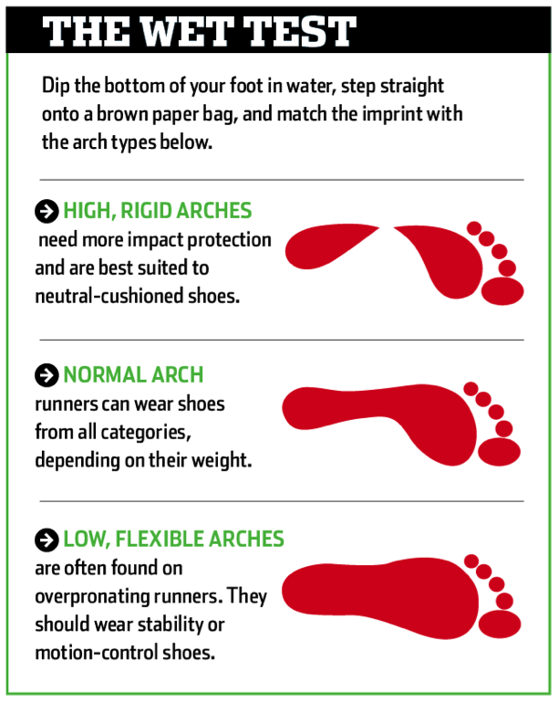
We need to understand that everyone pronates and that under/over pronating is completely okay. We just need to know what you do so we can know what to do going forward.

How many kind of shoes are there?
Going to a running shoe store can be a very daunting experience. You will find yourself staring at a wall of shoes that all look different and have different features. Shoes come in all kinds of variations these days. Many include gimmicks that promise amazing results. You need to understand that almost all of that stuff is purely for marketing purposes. Shoes break down into a few categories that we can focus on.

The first split we need to recognize is between “Racing” shoes and “Training” shoes. Racing shoes are only worn in races or in certain kinds of workouts. You will need a set of good trainers to do nearly all of your workouts in.

Next we can divide shoes by the kind of arch they are built for. Cushioned shoes are made for under pronators who land on the outside of their feet and stay there. Motion Control shoes are for over pronators who roll all the way in on their feet. In between are Neutral shoes. These do very little to help your feet because your feet don’t need the help. All of these shoes are made by brands you have probably heard of. There is another kind of shoe out there altogether. These are most often called barefoot, minimalist, or natural shoes. They are made to mimic barefoot running while still wearing shoes. These shoes will look different than you are used to and feel more like lace up slippers than anything else.
The last thing we need to understand is the concept of drop. The drop of a shoe is the difference in the thickness of the sole of the shoe (called the stack height) at the heel vs. the forefoot. In many standard shoes the stack height at the heel is 27milimeters at the heel and 10mm at the forefoot, making the drop 17mm. There is a large movement for zero drop shoes these days, meaning the heel is the same height as the forefoot. It does not mean that there is no height under either end, just that they are the same. Now you know everything you need to know about shoes.

Buying shoes

The best thing to do the first time you are buying shoes as serious runner is to go get some help. The best place in our area to get this help is at Big Peach Running Company. They will watch you run on a very fancy treadmill with cameras watching your feet. This will help identify the kind of shoe you should start in. They don’t sell bad shoes there. Once you have identified a general category of shoes to be in, picking the actual brand and model is all about picking the ones that feel good on your feet. Don’t be afraid of brands outside of the traditional powers. Shoe makers like Pearl are doing a great job right now.

Moving towards a neutral shoe

Everyone should start in a regular trainer that is recommended for your foot type. However, our goal is to steadily transition towards a more neutral shoe of that’s not where you start. Stability and motion control shoes are built to correct for issues like pronation and help your body when it is running the wrong way. However, the help they give is doing work that your body was meant to do for itself. Your lower body was designed to absorb impact and run long distances without getting injured. It has a great deal of internal shock absorption built in already. When we run in shoes that do this work for us, the natural shock absorbers in our lower legs get weak and turn off. This causes imbalances and can actually make you more injury prone. We need to teach your body to do the work it was meant to do for itself and become a more natural runner. This will be possible by working on your stride and gaining strength in your core and lower legs. We have to start out working with your body as it came to us. For most people this means a lifetime of running in stability shoes and with improper form. If you simply go out and buy a neutral or minimalist shoe and start doing all of your running in them, you will get injured because your foot is not ready for it. You need to spend time changing the way you run and getting strong before you do this. Here is the recommended process to switch shoes. There is a process for making this change that needs to be followed, however. Here is what I recommend.
- Buy a pair of performance neutral shoes with a lower drop that don’t go all the way to barefoot/zero drop minimalism. You will use these with your other stability shoes that you were running in before. The top selling model in this category is the Saucony Kinvara, but there are plenty of others out there that are great. You will notice that this shoe is a lot softer and more bendable than the ones you are used to. The Kinvara is neutral with a 4mm drop. It also weighs about 20% less than
- After working on form changes and strength exercises, wear your neutral shoes for warm up only for a few runs. Just warm up in them and then switch shoes for the bulk of your workout.
- Over the next few weeks continue to switch your shoes back and forth so you start getting used to them. You should working on your forefoot strike and natural running mechanics while you do this regardless of which shoes you are wearing.
- In week 2 or 3 of this process, wear the neutral shoes for all of one 30 minute easy run per week. Then in weeks 4 and 5 wear them for 2 or 3 shorter easy runs in the new shoes.
- After 4-6 weeks of steadily wearing your new shoes more and more, your old shoes will start to feel heavy and bulky. They won’t feel comfortable any more. This will let you know that it is time to fully switch and stop running in your old shoes.

The coolest thing that will happen is to check your footprint. After 4-6 months of work, do the wet footprint test again. If you started with a really flat foot, you will actually notice that it has changed towards a more neutral foot pattern. You will also feel lighter on your feet and hopefully faster as well. If you go through this process and move towards the first level of neutral shoes and love it, you can try it again and go all the way to a minimal/barefoot shoe. There are people on our team running in them and loving them. You just have to get there the right way.

How often should you buy shoes?
Running shoes last about 300-400 miles. This means that you will need a new pair every 3-4 months. More advanced runners will need them more often. In an ideal world, you would have two pairs of shoes that you are alternating your runs in. This will get you more miles out of each pair. The first time you go shopping, you should go to a knowledgeable running store like Big Peach. They are by far the best in our area. Do not go to their competitors in Merchants’ Walk. Definitely don’t go to a large general sports store. Once you have identified the right shoe for you, there is no reason you can’t start buying them on the internet at greatly reduced prices. Buying last year’s model is a great way to save money as there is virtually no difference in the shoes from one year to the next. Definitely use www.shoekicker.com to help you find the best price on the internet. I never pay full price for shoes and neither should you.

Now you know everything you need to know about buying running shoes. Go out and get some good ones and start logging those miles.

